Grades K-12
HANDBOOK
2022-2023

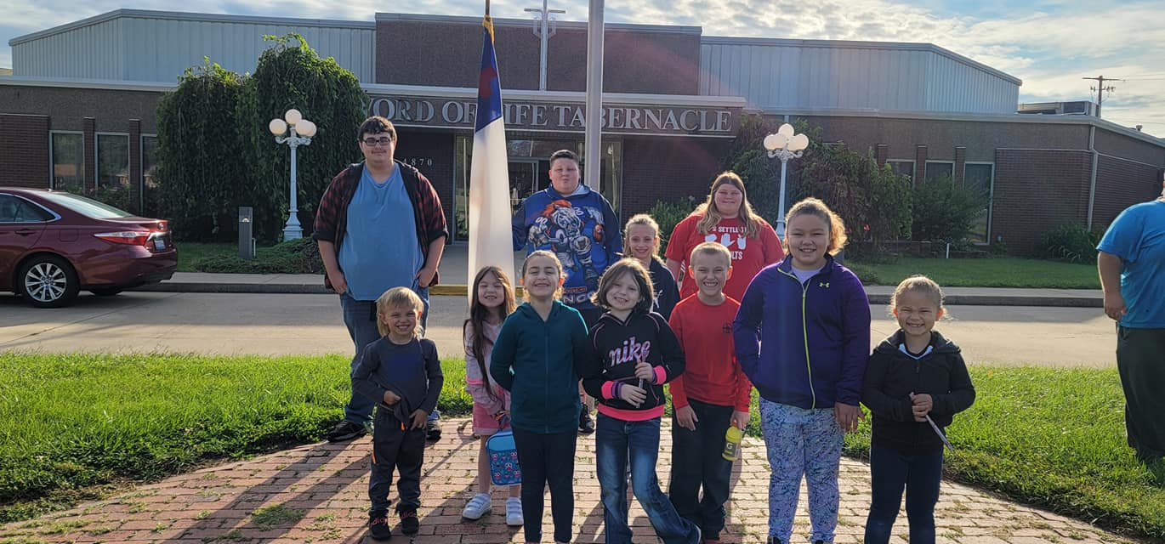
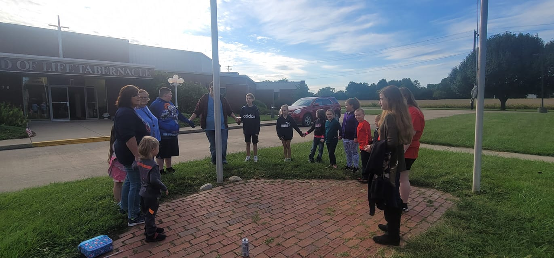
Word of Life Christian Academy

Word of Life Christian Academy
4870 Maryville Road
Mailing Address: Word of Life Christian Academy
P.O. Box 66
Granite City, Illinois 62040

Lobby Hours*: 7:45 a.m-8:20 a.m.
2:15 p.m.-3:30 p.m.

Office Hours: Both Lisa and Olivia are in classrooms during school months, so office hours vary. If you leave a voicemail, we will contact you as soon as time allows.
618-931-3744

*Lobby hours are offered for your convenience to pay any open invoices.

Word of Life Christian Academy operates as an educational nonprofit tax-exempt institution and does not participate in any state/federal scholarship or voucher programs.
Our Purpose ______________________________
The primary objective and purpose of Word of Life Christian Academy is to train the student in the knowledge of God and the Christian way of life and give the student an excellent education.
Our Commitment ______________________________
The teachers of Word of Life Christian Academy realize the solemn responsibility before God in molding the life and character of their students in order to give each of them a good foundation for the future. The administration and faculty demonstrate a caring concern for each student under their care.
Our Support Team ______________________________
Understanding each student’s academic success is directly related to the cooperative influence of parents and teachers, the administration team is available to facilitate communication, address individual needs, and guide the overall learning environment. Please do not hesitate to contact us so that we may better serve you.
Lisa Cochran & Olivia Saputo
(618) 931-3744 wordoflifegranite@gmail..com

Contents
2022 Academic Calendar 4
2023 Academic Calendar 4
Getting Started 5
Health Records 5
Beginning of School 6
First Day of Class 6
Academics 8
Student Health 9
Student Responsibilities 12
Student Safety 14
Services 15
Financial Information 16
General Information 18

Call 931-3744
Fax 931-4260
wordoflifegranite@gmail.com
Word of Life Christian Academy News
WordofLifeGranite.com

2022 Academic Calendar
August
15- Orientation and Open House (1:30-2:30 p.m.)
17- First Day of School (Dismissal 12p.m.)
September
5- Labor Day Holiday
15- Parent-Teacher Meeting (5-6 p.m.)
26- School Pictures

October
3-6- Fire Prevention Week
11- Columbus Day Holiday
31- Harvest Party

November
3- Donuts with Grownups
10- Parent Teacher Meeting (5-6p.m.)
13- Veteran’s Day Holiday (observed Monday)
22-24- Thanksgiving Holiday

December
22-Jan 5- Christmas Holiday

2023 Academic Calendar
January
9- School Resumes
12- Parent-Teacher Meeting (5-6 p.m.)
16- M.L.King Holiday
February
20- President’s Day Holiday

March
6- Casimir Pulaski Holiday
9- Parent-Teacher Meeting (5-6 p.m.)
April
6-17 Easter/Spring Holiday)

May
1*- WOLCA Holiday*
18- Tentative Last Day
*May 1 is tentatively set as a makeup school day, but if we do not have to make up a day lost due to school cancelation, this will be a Word of Life Christian Academy Holiday.
WOLCA meets the net number of school hours required by Illinois state law for all grades.

Getting Started
We are thankful you have chosen Word of Life Christian Academy For your children’s education. The following checklist is a guide to a smooth beginning.
Registration- Submit enrollment forms and registration fee.
Tuition- Divided into equal payments; first payment secures a position in class and is due by July 15.
Transportation- Sign up by July 15.
Extended School Day (ESD)- Sign up by July 15.
Open house and Orientation- August 15
First Day of Class- August 17, 8:30-12:00 p.m.

Health Records
Illinois law requires all students attending school for the first time to have a physical examination.
This means that Illinois law requires a physical examination form and certificate of immunization for all students entering kindergarten. The health form is to be completed by your physician. Immunization can be taken care of through your physician or local health department.
It will be necessary to bring your child’s health reports as stated above to the office prior to Orientation Day. No child may be permitted to enter class until this is completed as required by law.

Beginning of School
Open house
Annual Open house is held Sunday afternoon, 1:30-2:30 p.m.
Parents, children, and friends are invited to visit the school.

Orientation
It is important that each child be represented at orientation. Important classroom information will be given. If your child is using WOLCA transportation you will need to bring the transportation schedule. For the convenience of working parents, one orientation will be held the following Monday at 7 p.m. For those who miss these meetings, there will be a late orientation meeting, with a fee of $30 per student.

First Day of Class
The regular school day begins at 8:30 a.m. and continues until 3:00 p.m. On the first day of class, school will be dismissed at 12:00 p.m. In the morning before school, each child will enter through the front doors and stay in the foyer with a teacher. When bringing your child on the first day, it is best to leave the child with their teacher. When the parent remains in the foyer during drop off, it makes the period of adjustment more difficult for the student and the teacher. For increased building security, after the first week of school, children will need to enter the building without being accompanied by an adult. If children are brought to school after 8:30 a.m. you will need to text (618) 225-7712 for entrance instructions when you arrive.

Arrival and Dismissal
  - Car Students
Arrival: In order to provide for the safety of our students and to expedite the flow of traffic, we ask that you pull forward as far as you can to the end of the main entrance front sidewalk. Please use your automobile’s turn signal to indicate when turning. When stopping along the curb, drop your children off and move as quickly and as safely as possible so others can drop off their children. If you need to enter the lobby for payments, please park in the parking spaces. Do not leave your car unattended along the curb where students are dropped off.
Arrival Hours:
Students Registered for ESD: 7:30 a.m.
Normal Arrival: 8:00 a.m.
Students not registered for ESD will not be allowed to enter until 8:00 a.m.

Dismissal: All Students not enrolled in Extended School Day must be picked up within 15 minutes of dismissal. Students needing to be picked up later must enroll in ESD. Students not enrolled in ESD who are picked up late will be charged according to the following schedule and the fee must be paid at time of pick up.
After 3:15 p.m. ______ $10
After 3:45 p.m._____$20
After 4:15 p.m._____$30

  - Restriction of Child Pickup
If parents are divorced or separated and one parent is not allowed to see or pick up the child, we must have on file at the office a certified copy of the court order of final judgement.

Academics
  - Informing Parents
An online portal and mobile app allows parents to conveniently access their child’s academic progress and attendance record. Parents are encouraged to follow their child’s progress and use the portal to communicate with teachers. More information and log-in instructions will be provided at orientation.

  - School Conferences
Please feel free to consult with the school office regarding any problems or questions that concern your child. It is the desire of the administration and faculty to be of service to both parent and student, and each teacher welcomes a conference from any parent.
We do, however, urge that such conferences be made by definite appointment after class hours. We regret that we are unable to distribute any advertisements or solicitations for any businesses. If you need to talk to a member of our faculty, please contact the school office between 8:00 a.m. and noon. Your call will be returned as soon as possible.
We ask that you do not contact any member of faculty, teacher or administration, on their personal phone numbers after 4 p.m.

  - Observing the Classroom
If you wish to observe your child’s class during school hours, please contact the office to reserve a time. Families are always welcome to have lunch with their child during the student’s lunch time.

  - Graduation
In May, students participate in a formal evening graduation and awards ceremony. Families and friends are invited to attend.

  - Special Events
Field trips, spirit weeks, and class parties will be announced in the monthly newsletter.

  - Absences
When a child has been absent, he should bring a written excuse when he returns to school. Absences are marked as unexcused without the written excuse. Unexcused absences will result in zeros in all classes.
A student who must leave school with less than 2 hours in attendance will be counted absent for the entire school day.
Any student who is absent more that 15 days in a semester may not pass that semester’s work.

  - Attendance
A student must attend school the day of any activity (class party, graduation, etc..) in order to participate in that particular event.

  - Tardiness
Students arriving after 8:30a.m. will be marked tardy. 8:31a.m. is counted as tardy. Tardies are disruptive to the classroom and have an adverse effect on your child’s educational process. Tardies because of traffic will be counted as “traffic tardies.” An unexcused tardy will be given when a student accumulates three traffic tardies in one semester.

Student Health
  - Illness
For the welfare of your child and others in the school, all children who exhibit symptoms of illness (cough, sore throat, fever, etc..) must be kept at home. When the child is well enough to participate in a normal school day, please send hat, coat, etc.., as an aid to prevention of future illness. The class does participate in outdoor activities each day, weather permitting. If your child requires medication during school hours and we do not have signed authorization, it will be necessary for you to stop by and personally give it to him. Teachers cannot and will not be held responsible for carrying out these duties.

  - Medication
If a student is to take any medication while at school, he must have on file in the office the Authorization for Administration form. This form is available in the office or sent to your email. Prescription medication must have a physician’s signature; nonprescription medication may be signed by a parent or legal guardian. Each medication must have its own Authorization for Administration form. The medication to be dispensed will be kept in the First Aid area and dispensed by administration staff according to directions. Medicine must be properly labeled and in its original container.

  - Head-Lice Management
Students with a live louse and/or nits will not be permitted to be at school. Before returning to class, students must have their head checked by a faculty member, or bring a physician’s note.

  - Communicable Diseases
Word of Life Christian Academy desires to maintain a healthful school environment by instituting controls designed to prevent the spread of communicable diseases. The term “communicable disease” shall mean an illness which arises as a result of a specific infections agent which may be transmitted either directly or indirectly by a susceptible host or infected person or animal to other persons.
A teacher or administrative official who reasonably suspects that a student or employee has a communicable disease shall immediately notify the principal. Any student or employee with a communicable disease shall be temporarily excluded from school while ill and during recognized periods of communicability. If the nature of the disease warrant, an independent physician’s examination may be required. WOLCA reserves the right to make all final decisions necessary to enforce communicable disease policies and take necessary action to control the spread of communicable diseases within the school.

  - Reportable Communicable Diseases Include, but are not limited to:
Hemorrhagic Fevers
Hepatitis
Histoplasmosis
Human Immunodeficiency Virus (HIV)
Legionnaire’s Disease
Leptospirosis
Lymphogranuloma Venereum
Malaria
Measles (rubeola)
Meningitis
Meningococcal Disease
Mumps
Paralytic Shellfish Poisoning
Pertussis
Pesticide Poisoning
Pink Eye
Plague
Poliomyelitis
Psittacosis
Rabies
Acquired Immune Deficiency Syndrome (AIDS)
AIDS-Related Complex (ARC)
Amebiases
Anthrax
Bite by a potentially rabid animal
Botulism
Brucellosis
Campylobacterosis
Chancroi
Chicken Pox
COVID-19
Dengue
Diphtheria
Encephalitis
Enterovirus D68
Gonorrhea
Granuloma Inguinale
Hansen’s Disease (Leprosy)
Relapsing Fever
Ringworm
Rocky Mt. Spotted Fever
Rubella, including congenital
Salmonellosis
Scabies
Schistosomiasis
Shigellosis
Smallpox
Syphilis
Tetanus
Toxoplasmosis Acute
Trichinosis
Tuberculosis
Tularemia
Typhoid Fever
Typhus
Vibrio Cholera
Vibrio Infections
Yellow Fever

Student Responsibilities
  - Conduct
Word of Life Christian Academy is above all else, a Christian institution in both philosophy and practice; therefore, the goal of WOLCA is to provide the best possible learning environment in a Christian Atmosphere. We firmly believe there is no place at WOLCA for worldly practices or divisions common among other institutions. Students are expected to abide by the biblical principle, “Do unto others as you would have them do to you.” Word of Life Christian Academy has the reputation of having a student body with an excellent spirit with every student treated equally and fairly-regardless of nationality, race, or background.
A sense of need for spiritual growth in light of biblical principles has led Word of Life Christian Academy to adopt Standards of Conduct for middle school and high school students which are believed to be conducive to the environment that will promote the spiritual welfare of the student. Students are expected to abide by the Standards of Conduct whether at school, home, or elsewhere. Middle and High School students will not be admitted to class without a signed Standards of Conduct agreement on file at the Academy.
  - Accountability
Believing that accountability is necessary for the welfare of the student as well as the entire school, each teacher is given the responsibility of enforcing classroom regulations in accordance with school policy Christian principles set forth in the Scripture. Since the teacher is responsible to maintain proper classroom behavior, it becomes necessary to correct any behaviors that hinder the teacher or other students. Examples of typical corrective measures include student-teacher conferences, lunch detentions, student-administrator conferences, parent-teacher conferences, and Friday School. Students may be suspended or expelled for excessive detentions and behavior outside of the Standards of Conduct. A student suspended for any reason will receive zeros for any classes missed and may not be permitted to take exams missed. Behavior such as lying, stealing, cheating, vandalism, gang-related items or symbols, skipping school, or other misconduct may result in suspension or expulsion. Although this list of infractions is not exhaustive, it represents behavior that is not acceptable. Actions that threaten or jeopardize another’s ability to function safely will result in further corrective measures. Violence, bullying, fighting, or threats of any kind are not tolerated. This includes possession of anything that could be used as a weapon. Students backpacks, storage areas, and personal items are subject to search at any time, upon reasonable suspicion.
Any student who promotes division or a divisive spirit through social media, secret clubs, banners, flags, pictures, writing, slogans, music, or any harmful or divisive activism is out of harmony with the standards and Christian philosophy of Word of Life Christian Academy and may be withdrawn or refused re-enrollment at the discretion of the administration. Each student is fully responsible for the reputation he builds for himself, including online and social media.
Enrollment at Word of Life Christian Academy is a privilege, not a right. Students forfeit this privilege if they do not conform to the standards and ideals of work and life at Word of Life Christian Academy. Students who do not report violations of the Standards of Conduct may be subjected to disciplinary action.
Full cooperation is expected from both the student and the parents in the education of the student. If at any time the school feels the cooperation is lacking, the student may be requested to transfer out. Also, if the student’s behavior or attitude indicates an uncooperative spirit or one that is out of harmony with the spirit and standards of WOLCA, whether or not there is any definitive breach of conduct, he may be requested to transfer out. Please feel free to consult with administration about any problem or question that concerns the welfare of the students.
  - Dress
There are no regulations concerning uniform clothing; however, students should maintain a neat, conservative appearance at all school functions. Extreme fads should be avoided. Clothing that is ill-fitting, offensive, disruptive, divisive, or contrary to the Standards of Conduct, or otherwise inappropriate is not permissible. Sweatpants and pajamas are only to be worn on Special Days (pajama day, movie day, etc.). The school administration reserves the right to initiate new policies on new fads and changes in style throughout the year.

Student Safety
Since the health and safety of our students is extremely important to us, WOLCA has established safety protocols. We are consistently evaluating our policies and procedures to provide the best environment for our students.
  - Campus
Word of Life Christian Academy maintains a campus that is clean and safe. To set the proper example for our students, we request that adults refrain from the use of tobacco, drugs, alcohol, and similar products on campus.

  - Identification
Enrollments, payments, student check-in/check-out, and general inquiries are all handled in the front lobby/foyer. All adults will be required to provide identification before being admitted beyond the lobby. Leave large purses and bags in your vehicle.
  - Security
We work closely with local law enforcement to establish security protocols, and our limited-access building with continual video surveillance aids in keeping students and staff safe. Staff, students, and visitors are always monitored by camera. We encourage parents and students to report any suspicious activity (even on social media) to the principal.

Services
  - Transportation
Transportation services are offered and include morning and afternoon routes and is available for $20 per pay period. Transportation is done by WOLCA staff and includes house pick-up and drop-off. Transportation services are added on to your monthly tuition payments.
It is understood that transportation cannot wait at any house for more than 5 minutes. It will be necessary for you to bring your child to school if he is not ready at the pick-up time.
  - Lunch Service
A student lunch/activity card will be required for all students. The lunch/activity card can be used to purchase lunch or a beverage at lunch. Students may purchase lunch at $3 per day. For those who bring their lunch, a bottle of water may be purchased for $1. Lunch charges will appear at the end of each month on your statement. If a student forgets his lunch card, but needs to purchase lunch, a $1 service fee will be added. Students are encouraged to participate in this wholesome food program which receives no federal or state aid. This card also enables the student to enter any home sporting events and provides access to take library books home. Replacement cost for a lost or damaged card is $7.50.

Financial Information
New Students must pay a $35 nonrefundable/nontransferable registration fee at the time of registration. The tuition rate is $315 per payment. The first payment secures a position in class and must be paid no later than July 15. This amount is nonrefundable and nontransferable should the student cancel for any reason. If the July 15 deadline is not met, the student’s reservation will be cancelled to make room for those on waiting lists.
Book fees are due August 15. The tuition and fees for transportation and ESD will be divided into 10 monthly payments. Each payment covers approximately one-tenth of the total number of school days. Payment is due at the first of the month and is late if received after 4:15 P.M. on the tenth of the month. If the tenth falls on the weekend, the deadline is extended through Mon.
Covers Services
Payment Dates Late after 4:15 P.M. on From To
July 15 July 15 Open House . . . . . . . . . . . . . . . Sept.9
Sept.1 Sept.10 Sept. 10 . . . . . . . . . . . . . . . . . . .Oct. 9
Oct. 1 Oct. 10 Oct. 10 . . . . . . . . . . . . . . . . . . . .Nov. 9
Nov. 1 Nov. 10 Nov. 10. . . . . . . . . . . . . . . . . . . . Dec. 9
Dec. 1 Dec. 10 Dec. 10 . . . . . . . . . . . . . . . . . . . Jan. 9
Jan. 1 Jan. 10 Jan. 10 . . . . . . . . . . . . . . . . . . . . .Feb. 9
Feb. 1 Feb. 10 Feb. 10 . . . . . . . . . . . . . . . . . . . . Mar.9
Mar. 1 Mar. 10 Mar. 10 . . . . . . . . . . . . . . . . . . . .Apr. 9
Apr. 1 Apr. 10 Apr. 10 . . . . . . . . . . . . . . . . . . . . May 9
May 1 May 10 May 10. . . . . . . . . . . . . . . . . . . Last Day

Important: Any student whose account is not paid in full by May 10 will not be admitted to class May 17th and will not be permitted to participate in graduation ceremonies.
Prior to each payment date, the account holder will receive e-mail notifications that his statement is ready to view. If you are not signed up for paperless notifications, statements will be sent home with the oldest child in the family. Payments can be made online using Paypal or Venmo.
A late fee of $15 will be charged on any school account showing a balance of $10 or more after 4:15 P.M. on the tenth of the month. When the tenth is a weekend, tuition payments will be made on the following Monday without any late fees. Students will not be permitted to class and no schoolwork will be given if payments are one month in arrears. Students enrolled one day or more during a period will owe the full period’s tuition. There is a $25 fee for any returned checks. If two checks are returned, your account will be on a cash-only basis.
Word of Life Christian Academy endeavors to keep tuition rates low for the benefit of each parent. For this reason, we may conduct fundraising events throughout the year and anticipate each parent/child’s participation in helping raise additional funds needed for school projects. Participation is voluntary and door-to-door sales are not required or recommended. The school receives no state or federal funding other than a tax-exemption status. No student will be permitted to graduate until all tuition and fees are paid up to date. No school records, transcript, or graduation diploma will be release for any student when there is a balance owed on the student’s account. It is our policy not to prorate any charges.

  - Multiple child discount
The tuition rate is $315 per payment (10 monthly payments). Families with multiple children enrolled will receive the following discount each pay period. *
Second child . . . . . . . . . . . . . . . . . . . .$20 off tuition
Third and each additional child . . . . . $40 off tuition
*Discount applies only to children living at the same address

General Information

  - After-School Supervision
We encourage parents to pick up students promptly after dismissal. Word of Life Christian Academy is not responsible for any student not enrolled in ESD after 4 p.m. It is against school policy for students to stay after school in the parking lot, on the school grounds, or on school campus. 7th -12th grade students are permitted to stay after school on Thursdays if they are attending Soul’d Out Youth Group at Word of Life.

  - Student Automobiles
It is a privilege to be able to bring a car to school.
- All student-driven cars must be registered with administration.
- Each driver should be an example of courteous, careful driving habits. Follow the rules of the road and use turn signals.
- Cars are to remain parked until students leave at the end of the day.
- You may take an off-campus lunch with permission from parents and administration approval.
- Cars are not to be occupied during school hours, except during lunch, if you are permitted to be off campus.
- Music should not be heard from outside of the vehicle.
- No students, other than the driver, are permitted to be in the vehicle

Failure to observe these policies will necessitate cancellation of the privilege of bringing your car to school.

  - Classes/Clubs
Class and club meetings (S.T.E.A.M., drama, hospitality, etc.) provide avenues for leadership while students enjoy a fun social diversion during the school day. In class meetings, students join other classes for a time of informal interaction. Through clubs, students explore topics outside their scheduled class assignments. Each class and club will have membership dues that will cover the amount needed to accomplish the activities they plan for the year. Dues are not included in tuition and are to be paid at the time of club registration.

  - Phones/Devices
Use of cellphones and electronic devices (including electronic games, tablets, music devices, earbuds, etc..) is not permitted in the school or on school field trips. The teacher is permitted to confiscate any phones or devices that become a distraction in class. A courtesy phone is available in the office.

  - Lost and Found
Articles taken to lost and found may be redeemed for 30 cents. This policy has been established to teach our students personal responsibility. Unclaimed articles will be sold to students at periodic Lost and Found sales. Lost and found is open daily before and after school and at lunch time. WOLCA is not responsible for lost or stolen items.

  - Patriotism
Believing that Scripture teaches Christians to honor, give thanks for, and pray for government leaders, Word of Life Christian Academy seeks to foster a spirit of patriotism in the hearts of students. While the United States is imperfect, it is nevertheless blessed by God with liberties and opportunities seen few other places in the world. Students who are United States citizens are expected to respectfully participate in activities that promote a spirit of patriotism. This includes, but is not limited to, reciting the Pledge of Allegiance. Students who are not citizens of the United States are expected to show respect by quietly standing while others participate.

Thank you for choosing Word of Life Christian Academy for your child’s education. We look forward to the plans God has for the school year.

